Matthew Oliver

Spring 2025  DES 335-A

New World roleplaying game

# Important Information

#### Designer

Matthew Oliver

#### Instructor

Eric Cagle

#### President of DigiPen Institute of Technology

Claude Comair

#### Teaching Assistants

Caleb Starr-Kriss

Alex Koo

Gabriel Hoefler

#### Links to Art Used

<https://www.google.com/url?sa=i&url=https%3A%2F%2Fthenobleartist.com%2Frogue-concept-art%2F&psig=AOvVaw2vtkegiZNyXcHc8MPYZf-I&ust=1740872762105000&source=images&cd=vfe&opi=89978449&ved=0CBEQjRxqFwoTCODIyN3G54sDFQAAAAAdAAAAABAQ>

<https://shorturl.at/e12Rm>

<https://shorturl.at/daNyn>

<https://shorturl.at/3qDhV>

<https://shorturl.at/7O6I8>

Contents

Chapter 1: Introduction 3

Chapter 2: Making a Character 4

Choosing a Species 4

Choose a Background 4

Determining your Attributes 4

Select your Starting Feats 4

Starting Equipment 4

Leveling Up 4

Chapter 3: Species 5

Human 5

Wapiti (Elk Folk) 5

Ouaouron (Frog Men) 6

Mawa (Orangutan Men) 6

Iwana (Iguana Folk) 7

Chapter 4: Backgrounds 8

Blacksmith 8

Doctor 8

Hunter 8

Thief 8

Mage Apprentice 8

Chapter 5: Goods and Services 9

Currency 9

Bartering 9

Buying 9

Selling 9

Equipment 10

Quality 10

Size 10

Armor and Shields 10

Weapons 10

Other Equipment 10

Goods 11

Monster Parts 11

Herbs 11

Materials 11

Valuables 11

Trade Goods 11

Chapter 6: Using Attributes and Skills 12

Attributes 12

Strength 12

Dexterity 12

Constitution 12

Intelligence 12

Acuity 12

Will 12

Utility Skills 12

Athletics 13

Brawn 13

Stealth 13

Acrobatics [UPDATE REQUIRED BECAUSE OF: MANEUVERING COMBAT SKILL] 13

Fine Control 13

Analysis 13

Critical Thinking 13

Research 13

Physical Perception 13

Social Perception 13

Social Skills 13

Combat Skills 13

Evasion 14

Blocking 14

Initiative 14

Grappling 14

Mounting 14

Maneuvering 14

[ALL SKILLS BELOW ARE STILL IN THE THEORY STAGE AND ARE NOT INDICATIVE OF FINAL RULES] 14

Melee Fighting 14

Ranged Fighting 14

Magic Fighting 14

Presence 14

Profession Skills 14

Advancing Skills 14

Chapter 7: Adventuring 15

Spellcasting 16

# Chapter 1: Introduction

# Chapter 2: Making a Character

## Choosing a Species

The creation of every adventurer starts by choosing a species. The world of [WORLD NAME] contains a wide variety of intelligent species. Will you choose to be one of the Amphibian Folk? Or maybe one of the Ape Men? Various species can be found almost anywhere in the world of [WORLD NAME] and any background is available to any species, so feel free to choose whichever one looks like the most fun to you.

Your species affects several aspects of your character, including a bonus to one of your attributes, your starting language(s), your size, your base movement speed(s), and can include some other traits.

You can choose a species that suits the character you want to make or just go wild. Just because Ouaouran get a bonus to Dexterity doesn’t mean that you have to play a Dexterity based character. Be a Frog Wizard! Or maybe an Elk Assassin? The possibilities are endless!

## Choose a Background

Who were you before you became an adventurer? Were you a blacksmith? Maybe a thief? Your background can give you one or several bonuses to start with, giving you a head start on the road to building the adventurer you want.

Most backgrounds will let you start as a Novice in one of the Profession Skills and may give bonuses to other Skills as well. Your background will also give you a couple pieces of starting equipment, easing your initial spending.

## Determining your Attributes

All beings in [WORLD NAME] have six basic attributes. These are Strength, Dexterity, Constitution, Intelligence, Acuity, and Will. These attributes represent a being’s various physical and mental abilities.

At Level 1 all adventurers start with the same basic spread of stats. Choose two of your attributes to be Tier 3, three to be Tier 2, and one to be Tier 1.

It is recommended that you choose your attribute spread based on the kind of character you want to be. Are you going to be a sword-wielding knight? Strength and Constitution are your friends. Want to be a spell-slinging mage? Intelligence and Will are what you need. Choose an attribute spread that best fits the play style you’re going for.

## Select your Starting Feats

At level one every adventurer starts with the following: two Narrative Feats, one Combat Feat, one Profession Feat, and either a Martial Feat or a Magic Feat.

Your feats are what determines your adventurer’s playstyle so make sure to choose them based on who you want to play. Also make sure to choose them based on what feats you’ll have access to as you go down those trees, you might find that while one feat fits your playstyle better now, there might be feats in another section of the tree that will fit your character better.

## Starting Equipment

## Leveling Up

# Chapter 3: Species

## Human

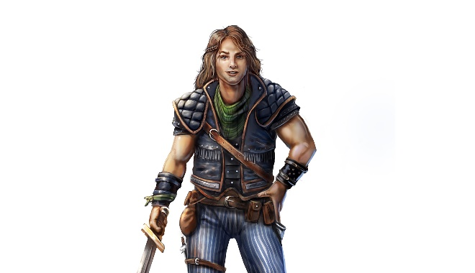

Bonuses

Humans are an extremely varied race, coming in all shapes and sizes. Choose one Attribute to increase by a tier.

Languages

[COMMON LANGUAGE], Outworld

Aging

Humans reach maturity at around the age of 20 and live until around 80.

Size

Humans are medium creatures.

Movement

Humans have a base walking speed of 45ft.

Appearance

Culture

History

Other Traits

## Wapiti (Elk Folk)

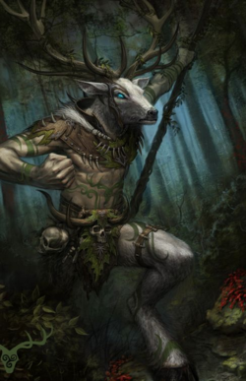

Bonuses

Wapiti are naturally strong, increase your strength attribute by one tier.

Languages

[COMMON LANGUAGE], [SYLVAN LANGUAGE]

Aging

Wapiti reach maturity at the age of five and live about forty years.

Size

Wapiti are medium creatures.

Movement

Wapiti have a base walking speed of 60ft.

Appearance

Culture

History

Other Traits

All Wapiti possess horns, which start growing once they reach maturity. These horns count as a natural weapon and can be found in [NATURAL WEAPONS APPENDIX]

## Ouaouron (Frog Men)

Wad-ah-rohn

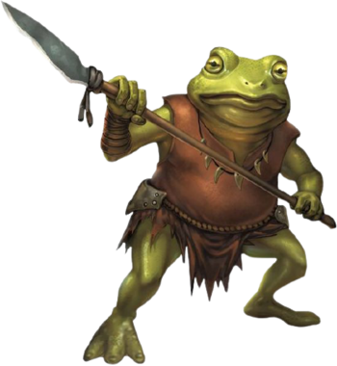

Bonuses

Ouaouron are naturally mobile, increase your dexterity attribute by one tier.

Languages

[COMMON LANGUAGE], [AMPHIB LANGUAGE]

Aging

Ouaouron are born as tadpoles, which gradually grow into adults, reaching maturity at the age of two. Ouaouron live until about twenty.

Size

Ouaouron are medium creatures.

Movement

Ouaouron have base walking and swimming speeds of 30ft.

Appearance

Culture

History

Other Traits

Ouaouron are natural jumpers and universally have the **Leap** ability, found in the [ABILITIES APPENDIX]

Ouaouron have a long, sticky tongue, which counts as a natural weapon, found in the [NATURAL WEAPONS APPENDIX]

## Mawa (Orangutan Men)

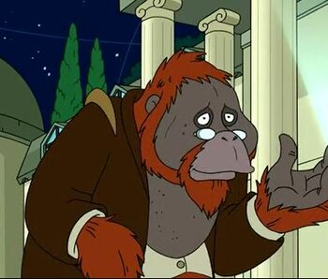

Bonuses

Mawa are naturally intelligent, increase your intelligence attribute by one tier.

Languages

[COMMON LANGUAGE], [APE LANGUAGE]

Aging

Mawa reach maturity at the age of 15 and live until around 60

Size

Mawa are medium creatures.

Movement

Mawa have base walking and climbing speeds of 30ft.

Appearance

Culture

History

Other Traits

## Iwana (Iguana Folk)

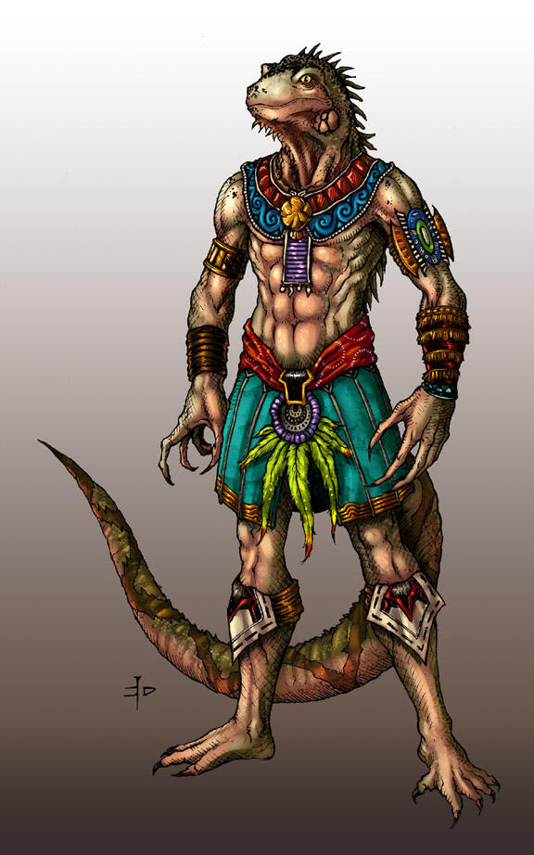

Bonuses

Iwana are naturally dexterous, increase your dexterity attribute by one tier

Languages

[COMMON LANGUAGE], [SOUTH AMERICA REPTILE LANGUAGE]

Aging

Iwana reach maturity at the age of 5 and live to around 30

Size

Mawa are medium creatures.

Movement

Mawa have base walking and swimming speeds of 30ft.

Appearance

Culture

History

Other Traits

# Chapter 4: Backgrounds

## Blacksmith

Bonuses

Adventurers who have a background in smithing start as a Novice in the Smithing Profession Skill

Equipment

You start with Smithing Tools and a Low-Quality item of your choice, which you forged.

Description

## Doctor

Bonuses

Adventurers who have a background as a doctor starting as a Novice in the Physician Profession Skill

Equipment

You start with a Medical Kit

Description

## Hunter

Bonuses

Adventurers who have a background as a doctor starting as a Novice in the Hunting Profession Skill

Equipment

You start with a Survival Kit and a Low Quality Long Bow

Description

## Thief

Bonuses

Adventurers who have a background as a thief starting as a Novice in the Thievery Profession Skill

Equipment

You start with a Lockpicking Kit and 10 extra gold

Description

## Mage Apprentice

Bonuses

Adventurers who have a background as an apprentice starting as a Novice in the Arcane Magic Skill

Equipment

You start with a Spell Book and a Low-Quality Staff

Description

# Chapter 5: Goods and Services

## Currency

Currency in the world of [WORLD NAME] comes in two main forms. The Human kingdom of [HUMAN KINGDOM NAME] uses coins made of Gold, Silver, and Copper, with 100 Copper equaling 1 Silver, and 100 Silver equaling 1 Gold. The Native Tribes and Empires all use World Seeds as currency.

The Humans use what they view as “Precious Minerals,” to make their currency. They mine up the raw, untapped ores of [WORLD NAME], transport them, process them, and turn them into coins. These coins can then be used to purchase goods and services. The entire Human economy runs off these minerals, and they always want more. After they’ve been turned into coins the Humans name them. The gold coins are called “Landings,” the silver are “Foundings,” and the copper are “Prosperings.” Those are the official names, but most people call them “Lings,” “Fings,” and “Pings,” for gold, silver, and copper respectively.

The Natives have a very different system of “economy.” The Natives use an item called a “World Seed,” which like coins can be exchanged for goods and services. That, however, is the only similarity. First, World Seeds don’t come from mining. Instead, World Seeds are occasionally given out to the various Native Species by the People of the World. These People of the World live in the World Forests sprinkled around [WORLD NAME], and bring the World Seeds to the various peoples. That is the extent of the Human’s knowledge of the process, and it is true the no one knows where the World Seeds come from or how they are made. But, what the Humans don’t know is that the World Seeds actually have a use, unlike their coins. When a World Seed is planted, it grows into whatever plant *or* animal that the environment it’s in is currently lacking.

## Bartering

### Buying

Goods and Services in [World Name] tend to have two prices associated with them. The first is the Human Price, or what you should expect to pay in a Human settlement. The second is the Native Price, or what you should expect to pay in any Native settlement.

The different currencies are generally not exchangeable, Natives will not allow Humans to have World Seeds and have no use for coins. So, trading between Humans and Natives is generally only done through useable goods, things like food or materials. This means that any Human adventurers will never be given World Seeds in payment, it will always be something else. The only exception is Humans who are completely trusted, which is exceedingly rare.

The prices listed on all entries are the default, but can be brought down through use of the Persuasion Utility Skill. Prices listed as “HC,” are the cost in Human Currency, and prices listed as “NC,” are the cost in Native Currency.

### Selling

When selling goods it’s important to remember that the price you will get is dependent on how much the buyer wants or needs that good. If you’re trying to sell gear to a town with several blacksmiths, then you’re not going to get a good price. That said different kinds of goods will have different markdowns so in general here’s what you should expect:

#### Armor, Weapons, and Other Equipment

Typically, undamaged Armor, Weapons, or Other Equipment will sell for about 70% of the listed price.

#### Monster Parts

Monster Parts are very dependent on the rarity of the monster and who you’re selling to, but you can expect to get around 60-80% of the listed price.

#### Herbs

Useful Herbs are very dependent on the availability of that Herb, but typically sell for 70-90% of the listed price.

#### Materials

Materials are usually bought in bulk, which means the cut is much better, usually around 90% of the listed price.

#### Valuables

Valuables tend to sell for a lot, but also have a very high markup. Around 40% of the listed price is common.

#### Trade Goods

Trade Goods are unique in that they are commonly used directly for bartering, including bartering between Humans and Natives. Because of this Trade Goods are usually worth 100% of the listed price.

## Equipment

BECAUSE OF SIZE LIMITATIONS, ALL ITEM TABLES CAN BE FOUND IN [EQUIPMENT APPENDIX]

### Quality

### Size

### Armor and Shields

Armor falls into five categories: Very Light, Light, Medium, Heavy, and Very Heavy. Wearing Armor provides a passive reduction to all damage of the Damage Type(s) covered by that Armor. Some Armor will also have other bonuses or penalties, so it’s important to choose armor that fits your playstyle.

Shields provide a bonus to your ability to block attacks, and sometimes have attacks of their own. Shields come in three categories: Small, Medium, and Large, each category up increases the bonus to blocking, but also introduces new penalties.

#### Armor

|  |  |  |  |  |  |  |  |
| --- | --- | --- | --- | --- | --- | --- | --- |
| Name | Category | HC | NC | Weight | Quality | General Properties | Armor Properties |
|  |  |  |  |  |  |  |  |
|  |  |  |  |  |  |  |  |
|  |  |  |  |  |  |  |  |
|  |  |  |  |  |  |  |  |
|  |  |  |  |  |  |  |  |

### Weapons

Weapons fall into two categories: Melee and Ranged, with some weapons technically falling into both. All weapons have associated Attacks, which can be used while the weapon is being wielded. Weapons also have their own associated Weapon Skill, which is unique per weapon. Weapon skills can have a variety of associated feats, from increasing the damage of attacks to unlocking new abilities. These Weapon Skills can be found in [FEAT APPENDIX]

### Other Equipment

There are plenty of items that can help you on your journey. Whether it’s rope or ball bearings, someone is going to find it useful, equipment comes in all shapes and sizes, but generally falls into the following categories:

#### Ammunition

All ranged weapons take some form of ammunition. Ammunition is typically sold, and priced, in terms of bundles. The amount of ammunition in a bundle is dependent on the ammo, but generally it’s 20 pieces per bundle.

#### Gear

Gear includes a wide variety of things but be summarized as any useful item someone can carry. This includes things like rope, which has a variety of uses. Handcuffs also fall under Gear, but who knows what you’ll end up using those for?

#### Tools

Tools and Tool Kits are used to perform Profession Checks. For example, you can’t attempt to smith something unless you have access to all the necessary Smithing Tools.

#### Kits

Kits are unique in that they’re just a variety of useful items all packaged together in a convenient little bundle. An Adventuring Kit for example contains generally useful things like a Backpack, Rope, Flint and Steel, and some other goodies.

#### Containers

Not everyone can carry 50lbs worth of gear in their pockets, most people are going to put it in a container of some kind. Containers have a set amount of weight that they can hold and always count as weighing this much when carried. However, anything that is put inside a container does not add its weight to a character’s Encumbrance.

## Goods

### Monster Parts

### Herbs

### Materials

### Valuables

### Trade Goods

# Chapter 6: Using Attributes and Skills

All Attributes and Skills have five ranks, representing a character’s aptitude with that Attribute or Skill. These ranks range from 1 to 5, with 1 representing the lowest level of ability and 5 the highest.

## Attributes

Attributes fall into two types, Physical and Mental. Attributes also have five ranks, similar to Skills. These ranks indicate a character’s ability in that Attribute.

The first type is the Physical type, this includes Strength, Dexterity, and Constitution. These three Attributes affect a character’s physical stats.

The second type is the Mental type, this includes Intelligence, Acuity, and Will. These three Attributes affect a character’s mental stats.

### Strength

Strength represents a character’s physical might. How good is someone at lifting things? Hitting things? Carrying things? All of these are determined by a character’s Strength. Strength affects: Accuracy and Damage with some Melee, Strength-based Skills, Blocking, and a character’s Carrying Capacity. The five Strength ranks are: Atrophied, Weak, Fit, Strong, and Herculean.

### Dexterity

Dexterity represents a character’s physical mobility. How good is someone at dodging things? Performing Acrobatics? Being sneaky? All of these are determined by a character’s Dexterity. Dexterity affects: Accuracy and Damage with Ranged and some Melee, Evasion, and Dexterity-based Skills. The five Dexterity ranks are: Clumsy, Uncoordinated, Nimble, Graceful, and Cat-like.

### Constitution

Constitution represents a character’s physical toughness. How good is someone at taking hits? Resisting Poison and Disease? Healing? All of these are determined by a character’s Constitution. Constitution affects: Health and Injury Tolerance, resistance to Poison and Disease, and Natural Healing. The five Constitution ranks are: Sickly, Delicate, Healthy, Robust, and Impervious.

### Intelligence

Intelligence represents a character’s mental prowess. How knowledgeable is someone? How easily do they learn new things? How good are they at problem solving? All of these are determined by a character’s Intelligence. Intelligence affects: Accuracy and Damage with Arcane Magic and Intelligence-based Skills. The five Intelligence ranks are: Slow, Dumb, Competent, Bright, and Genius.

### Acuity

Acuity represents a character’s mental sharpness. How witty is someone? How good are they in social scenarios? How perceptive are they? All of these are determined by a character’s Acuity. Acuity affects: Attack and Damage with Spiritual Magic and Acuity-based Skills. The five Acuity ranks are: Dull, Absent-Minded, Sharp, Keen, and Witty.

### Will

Will represents a character’s mental toughness. How resilient is someone? How strong is their mental fortress? How well do healing spells work on them? All of these are determined by a character’s Will. Will affects: Resistance to Mental Attacks and how well Healing Spells work on them. The five Will ranks are: Spineless, Cowardly, Determined, Stalwart, and Unbreakable.

## Utility Skills

Utility Skills are used to represent a character’s ability in specific situations. For example, a character’s ability to swim is not useful all the time, but there could be a scenario in which being good at swimming is useful. All Utility Skills have associated Feat Trees, which represent a character’s general ability with that skill, and their ability in the various subcategories of that skill. Utility Skill Feat Trees can be found in [FEAT APPENDIX].

### Athletics

Athletics is a Strength-Based skill. Athletics represents a character’s ability to do Strength-Based movement. The subcategories of Athletics and examples of things you might make Athletics checks for are: Running, Jumping, Swimming, and Climbing.

### Brawn

Brawn is a Strength-Based skill. Brawn represents a character’s ability to do Strength-Based actions. The subcategories of Brawn and examples of things you might make Brawn checks for are: Lifting, Carrying, Throwing, and Smashing.

### Stealth

Stealth is a Dexterity-Based skill. Stealth represents a character’s ability to avoid detection. The subcategories of Stealth and examples of things you might make Stealth checks for are: Sneaking, Disguising, Trailing, and Distracting.

### Acrobatics [UPDATE REQUIRED BECAUSE OF: MANEUVERING COMBAT SKILL]

Acrobatics is a Dexterity-Based skill. Acrobatics represents a character’s ability to do Dexterity-Based movement. The subcategories of Acrobatics and examples of things you might make Acrobatics checks for are: Tumbling, Vaulting, Balancing, and Weaving.

### Fine Control

Fine Control is a Dexterity-Based skill.   
Fine Control represents a character’s ability to perform actions requiring fine motor skills. The subcategories of Fine Control and examples of things you might make Fine Control checks for are: Catching, Manipulating, Grabbing, and Artistry.

### Analysis

Analysis is an Intelligence-Based skill. Analysis represents a character’s ability to reason or understand. The subcategories of Analysis and examples of things you might make Analysis checks for are: Identifying, Examining, Understanding, and Recognizing.

### Critical Thinking

Critical Thinking is an Intelligence-Based skill. Critical Thinking represents a character’s ability to reason or deduce. The subcategories of Critical Thinking and examples of things you might make Critical Thinking checks for are: Reasoning, Problem Solving, Strategizing, and Evaluating.

### Research

Research is an Intelligence-Based skill. Research represents a character’s ability to find information, and learn about, a topic. The subcategories of Research and examples of things you might make Research checks for are: Investigation, Interpretation, Compilation, and Sourcing.

### Physical Perception

Physical Perception is an Acuity-Based skill. Physical Perception represents a character’s ability to notice things around them. The subcategories of Physical Perception and examples of things you might make Physical Perception checks for are: Spotting, Smelling, Hearing, and Tasting.

### Social Perception

Social Perception is an Acuity-Based skill. Social Perception represents a character’s ability to notice things about people around them. The subcategories of Social Perception and examples of things you might make Social Perception checks for are: Honesty, Emotions, Intentions, and Influence.

### Social Skills

Social Skills is an Acuity-Based skill. Social Skills represents a character’s ability to interact with other people. The subcategories of Social Skills and examples of things you might make Social Skills checks for are: Deception, Persuasion, Intimidation, and Performance

## Combat Skills

Combat Skills are used to represent a character’s abilities in a combat situation. For example, the Blocking and Evasion skills are used to avoid damage when attacked. Like Utility Skills, Combat Skills all have associated Feat Trees, found in the [FEAT APPENDIX]

### Evasion

Evasion is a Dexterity-Based skill. Evasion is used when taking the Evade Reaction. The subcategories of Evasion and examples of things you can use the Evasion Skill for are: Dodging, Redirecting, and Sidestepping.

### Blocking

Blocking is a Strength-Based skill. Blocking is used when taking the Block Reaction. The subcategories of Blocking and examples of things you can use the Blocking Skill for are: Parrying, Bracing, and Covering.

### Initiative

Initiative can be a Dexterity or Acuity based skill. Initiative is used when making your Initiative Roll at the beginning of a Round of Combat. The subcategories of Initiative and examples of things you can use the Initiative Skill for are: Timing, Reflexes, and Adaptability.

### Grappling

Grappling can be a Dexterity or Strength based skill. Grappling is used when taking the Grapple Action or the Escape Action. The subcategories of Grappling and examples of things you can use the Grappling Skill for are: Clinching, Escaping, and Controlling.

### Mounting

Mounting can be a Dexterity or Strength based skill. Mounting is used when taking the Mount Action or the Remove Action. The subcategories of Mounting and examples of things you can use the Mounting Skill for are: Climbing, Dismounting, and Removing.

### Maneuvering

Maneuvering is a Dexterity-Based skill. Maneuvering is used when moving around during Combat. The subcategories of Maneuvering and examples of things you can use the Maneuvering Skill for are: Positioning, Mobility, and Engagement.

### [ALL SKILLS BELOW ARE STILL IN THE THEORY STAGE AND ARE NOT INDICATIVE OF FINAL RULES]

### Melee Fighting

Melee Fighting is not used for any checks, instead levels in Melee Fighting can unlock new Actions and Reactions to use in Combat, as well as various bonuses. The subcategories of Melee Fighting and examples of things you can use the Melee Fighting Skill for are: One-Handed Weapon Fighting, Two-Weapon Fighting, Unarmed Fighting, and Two-Handed Weapon Fighting.

### Ranged Fighting

Ranged Fighting is not used for any checks, instead levels in Ranged Fighting can unlock new Actions and Reactions to use in Combat, as well as various bonuses. The subcategories of Ranged Fighting and examples of things you can use the Ranged Fighting Skill for are: Short-Ranged Weapon Fighting, Long-Ranged Weapon Fighting, and Throwing Weapon Fighting.

### Magic Fighting

### Presence

## Profession Skills

Coming in 2.0

## Advancing Skills

[SKILL ADVANCEMENT IS UNDER WORKS, I HAVE SEVERAL POSSIBLE SYSTEMS IN MIND]

Get different kinds of XP when performing different actions and spending that to gain new feats

Milestone leveling where you get to select a set number of new feats every level

Getting different kinds of points after every session depending on what you did that session and spending them to gain new feats

# Chapter 7: Adventuring

# Spellcasting